**Monkchester Road Nursery School - Mathematics Intent and Implementation**

Maths is an important part of learning for all children in the early years and receiving a good grounding in maths is an essential life skill. As well as helping children develop numeracy, it helps skills such as problem solving, understanding and using shapes and measure and developing their own spatial awareness.

At Monkchester Road Nursery we want our children to become confident mathematicians who can apply what they have learnt to real life experiences. Children learn about maths through play and in their daily experiences at Nursery, inside and outdoors. When staff make maths activities more meaningful to children and allow them to use maths hands on it is all the better.

Children in the playgroup at Monkchester Road Nursery are exposed to a variety of interesting and stimulating objects and resources to explore, including toys that play music or make noises when shaken or moved in a particular way (cause and effect toys). The environment is rich in resources that relate to numbers and counting. We have a wide variety of equipment that can be sorted or matched and endless opportunities for ‘filling and emptying’. These opportunities develop and increase as children move through the Nursery with carefully planned steps in their learning mapped out in our planning programmes.

From the playgroup and upwards children gain an awareness of time as staff support them to follow daily routines – singing songs, following visual timetables and using picture prompts. Number and counting rhymes are an integral part of the nursery day at each stage of our children’s learning. The songs we use are planned to match children’s understanding of mathematical concepts at each stage of their development. As our children’s mathematical understanding grows staff use their knowledge and expertise to plan for a high-quality learning environment, which provides them with many opportunities to explore different aspects of number, shape, space and measures. Concept development is planned in to our opportunities as children progress through each year at Nursery.

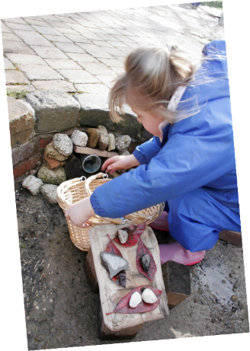The environment both inside and outside is full of mathematical opportunities and has exciting things for children to explore, sort, compare, count, calculate and describe including ‘loose’ parts play and various construction materials on a small and large scale. We use our forest and garden activities to introduce children to wide ranging natural materials and bring these inside as part of our collections for children to sort, match and count. Through play in our workshop, children use to use space, shapes and measures for a purpose within their models and constructions. We use our cookhouse weekly to help children develop life skills. They use measuring for a purpose as they follow picture recipes to cook their own foods. With a combination of direct group teaching, objective led planning and observing children’s independent play, staff model new language and support the children to be creative and critical thinkers, using their mathematical awareness to have a go and become problem solvers.

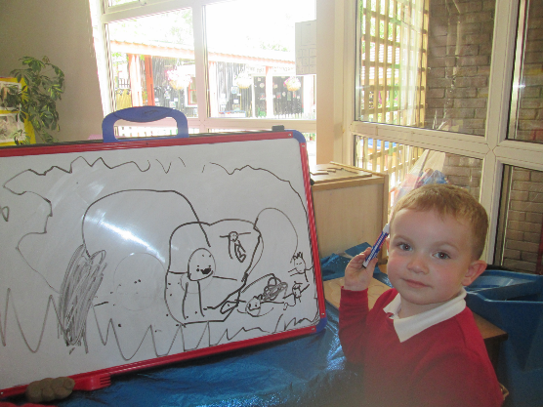

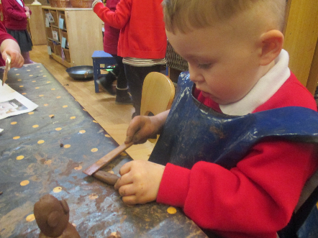

Our continuous provision which is evaluated and updated regularly provides endless opportunities for children to consolidate and revisit their mathematical knowledge and understanding in different ways. Our Maths Sacks are sent home weekly to encourage parents to get involved in their children’s learning and to encourage children to play and talk about maths in fun activities at home as well as at school. We encourage parents and carers to come along to our Stay and Make activities each half term and these always include an element of mathematics. We also offer Stay and Bake activities where Parents/Carers visit Nursery and Playgroup to take part in cooking activities with their children. We also provide Parent/Carer Guides to help families support children’s mathematical learning at home through easy and fun games and everyday routines.

